**IBM App Connect Designer Instance**

1. Access the Platform Navigator. Login to the RedHat OpenShift Container Platform Console using the url, userid and password.

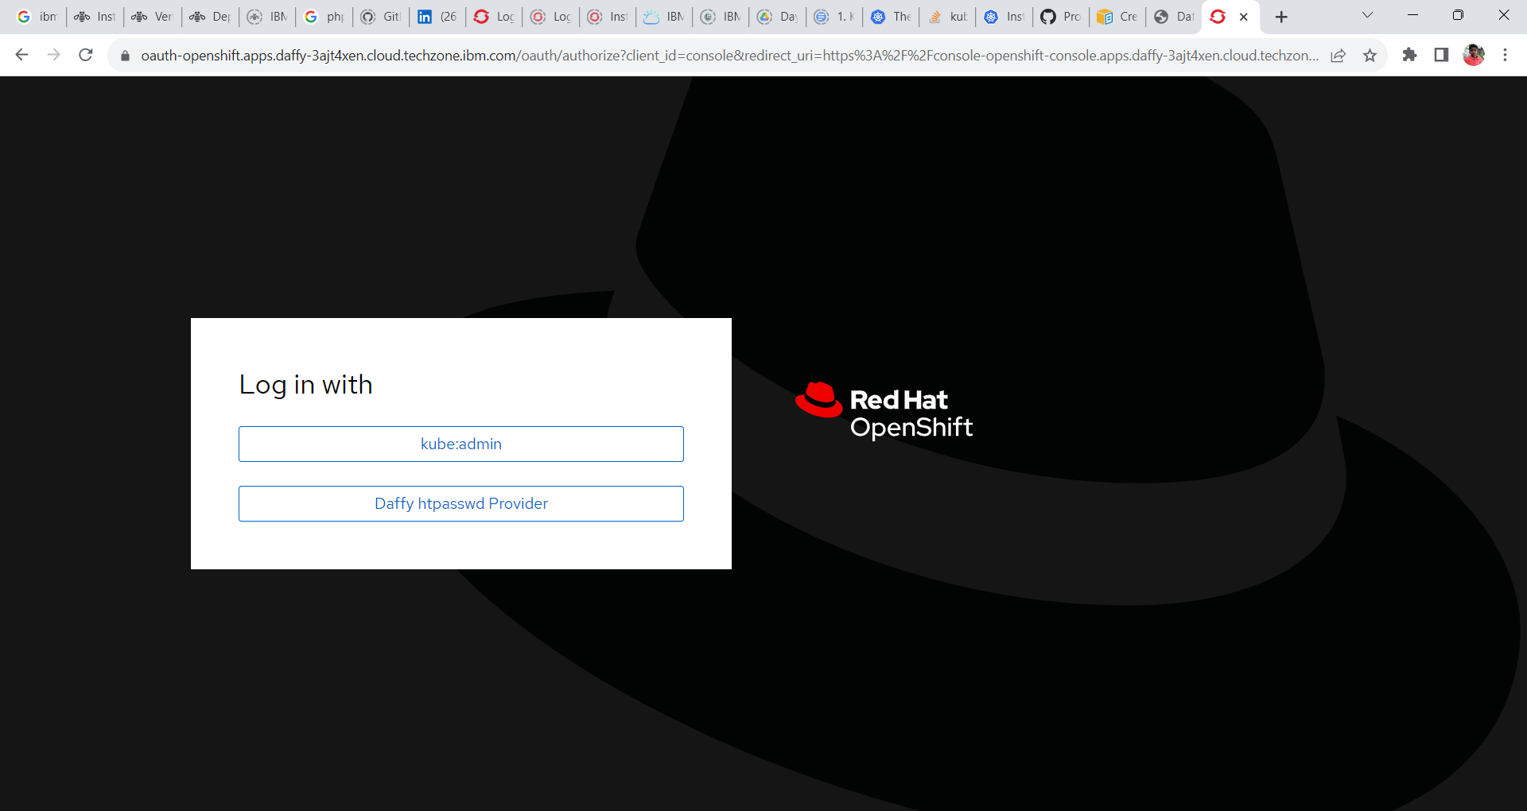

2. Goto **Network -> Routes** and change the project to CP4I.

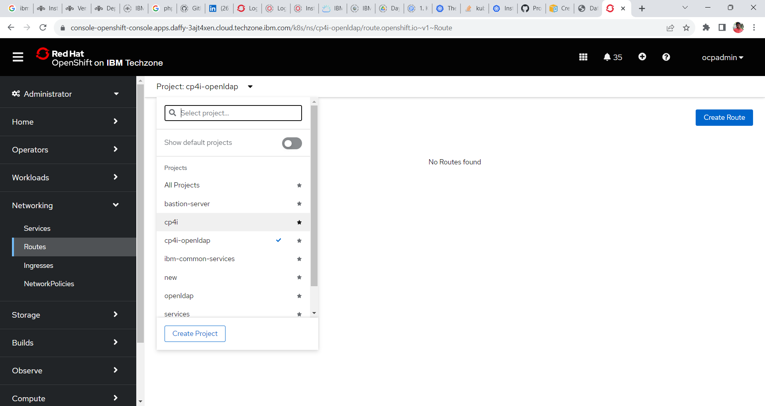

3. Search for Platform-navigator-pn or the name of the platform navigator you have provided and click on the url under location tab to open cp4i Platform UI.

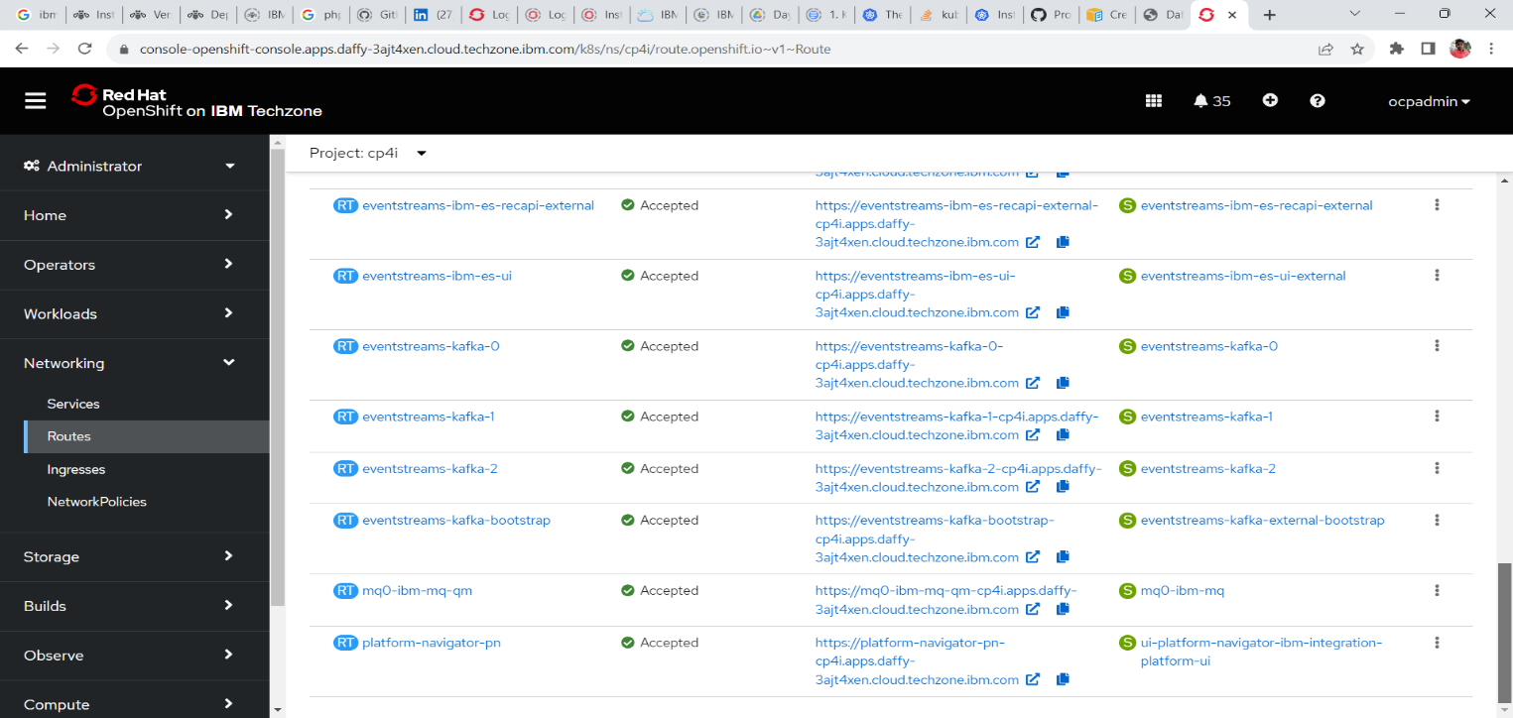

4. On clicking, cloud pak for integration Platform Navigator login screen is seen.

**Log in with = IBM Provided credentials**

**Username = admin**

**Password = < Need to accessed from secrets>**

**Access the password for platform navigator**

1. In OpenShift Web Console go to **Workload -> Secrets** and change the project **ibm-common-services**.

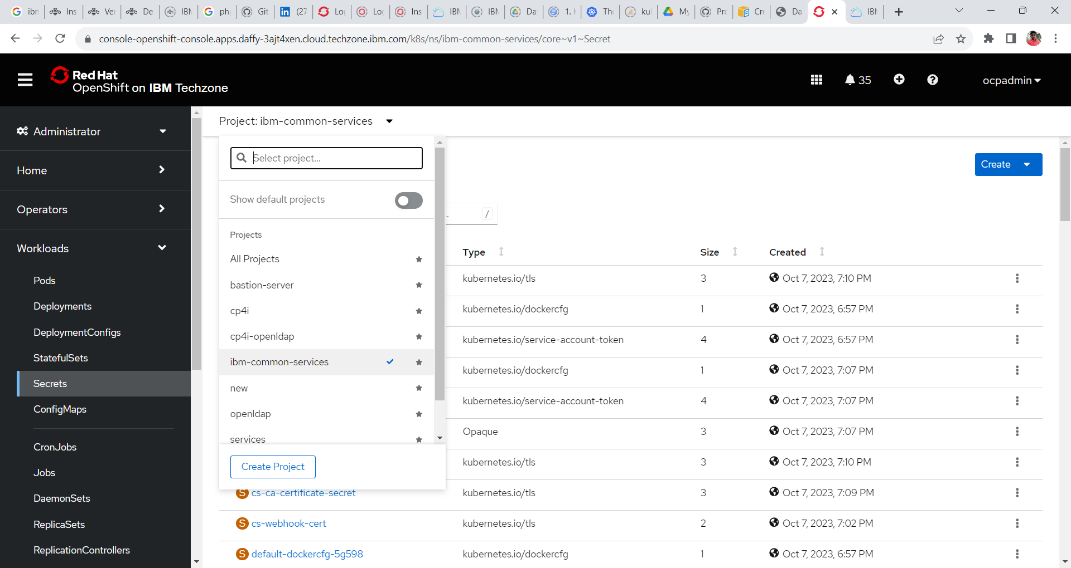

2. Search for the following secrets **platform-auth-idp-credentials** and click to open the same.

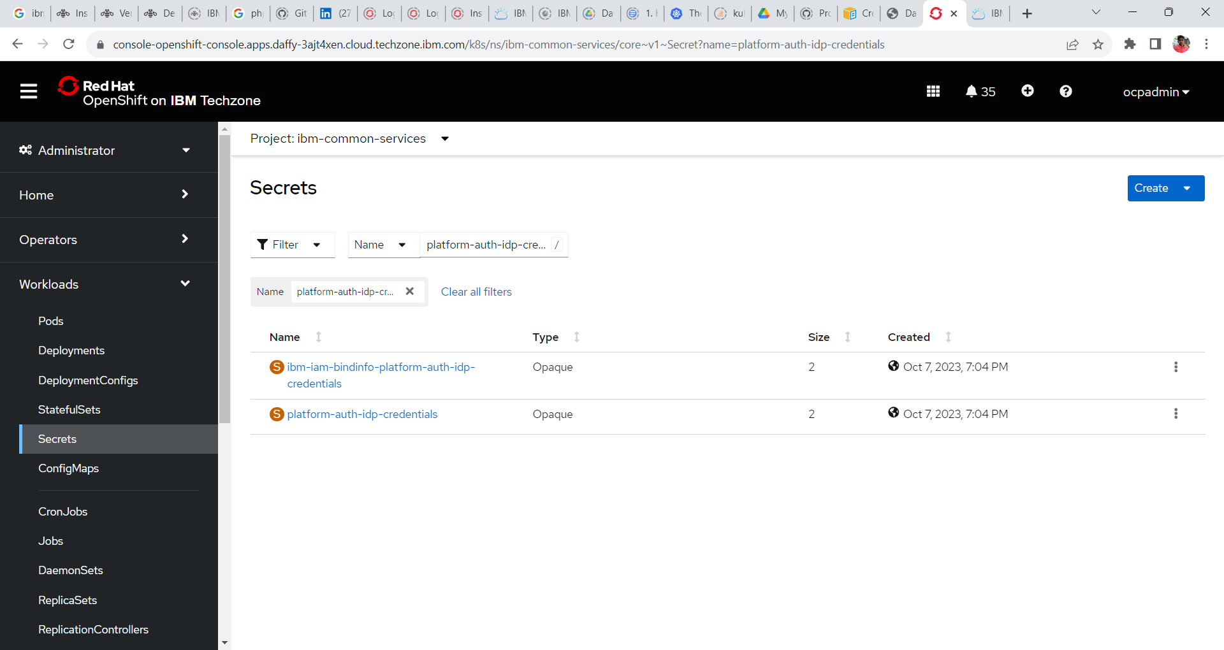

3. Goto the bottom of the screen and click on reveal values to reveal the username and password for the CP4I platform UI.

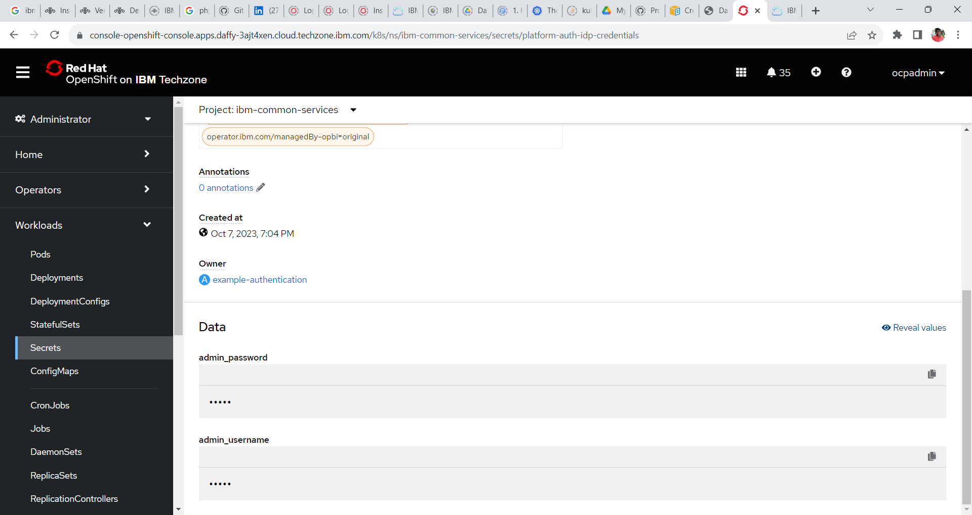

4. Copy the password and login to CP4I platform Navigator.

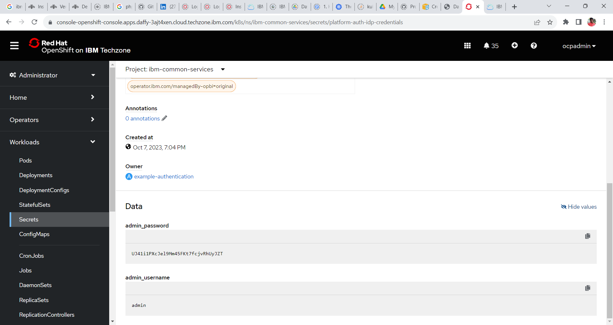

**Click to copy.**

**Platform Navigator**

5. Login to the platform Navigator

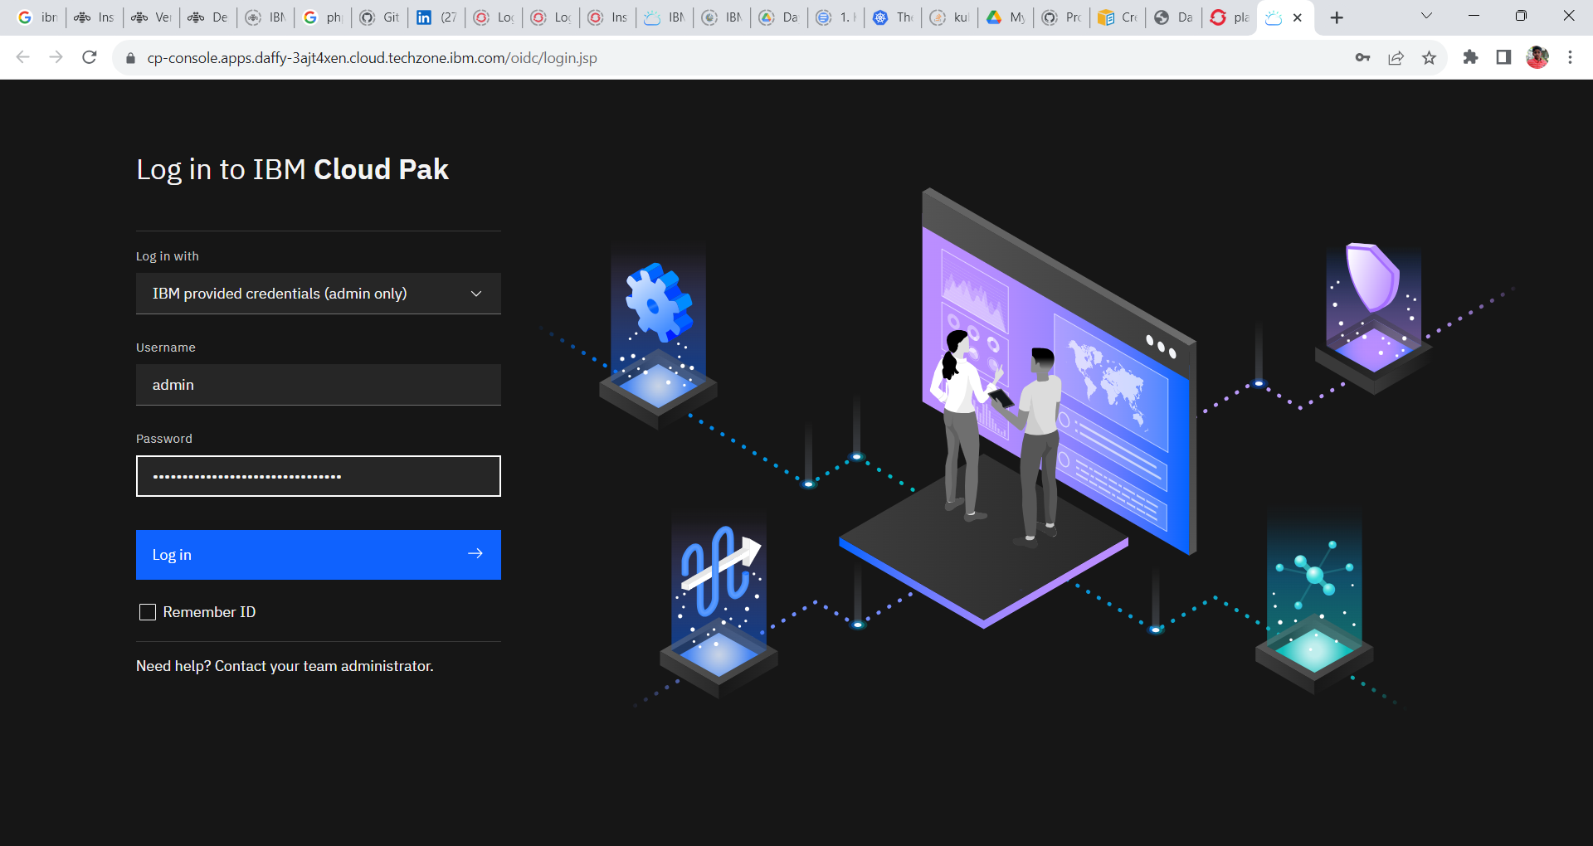

6. Click the integration instances tile or click on menu and click Administration and click on Integration Instances.

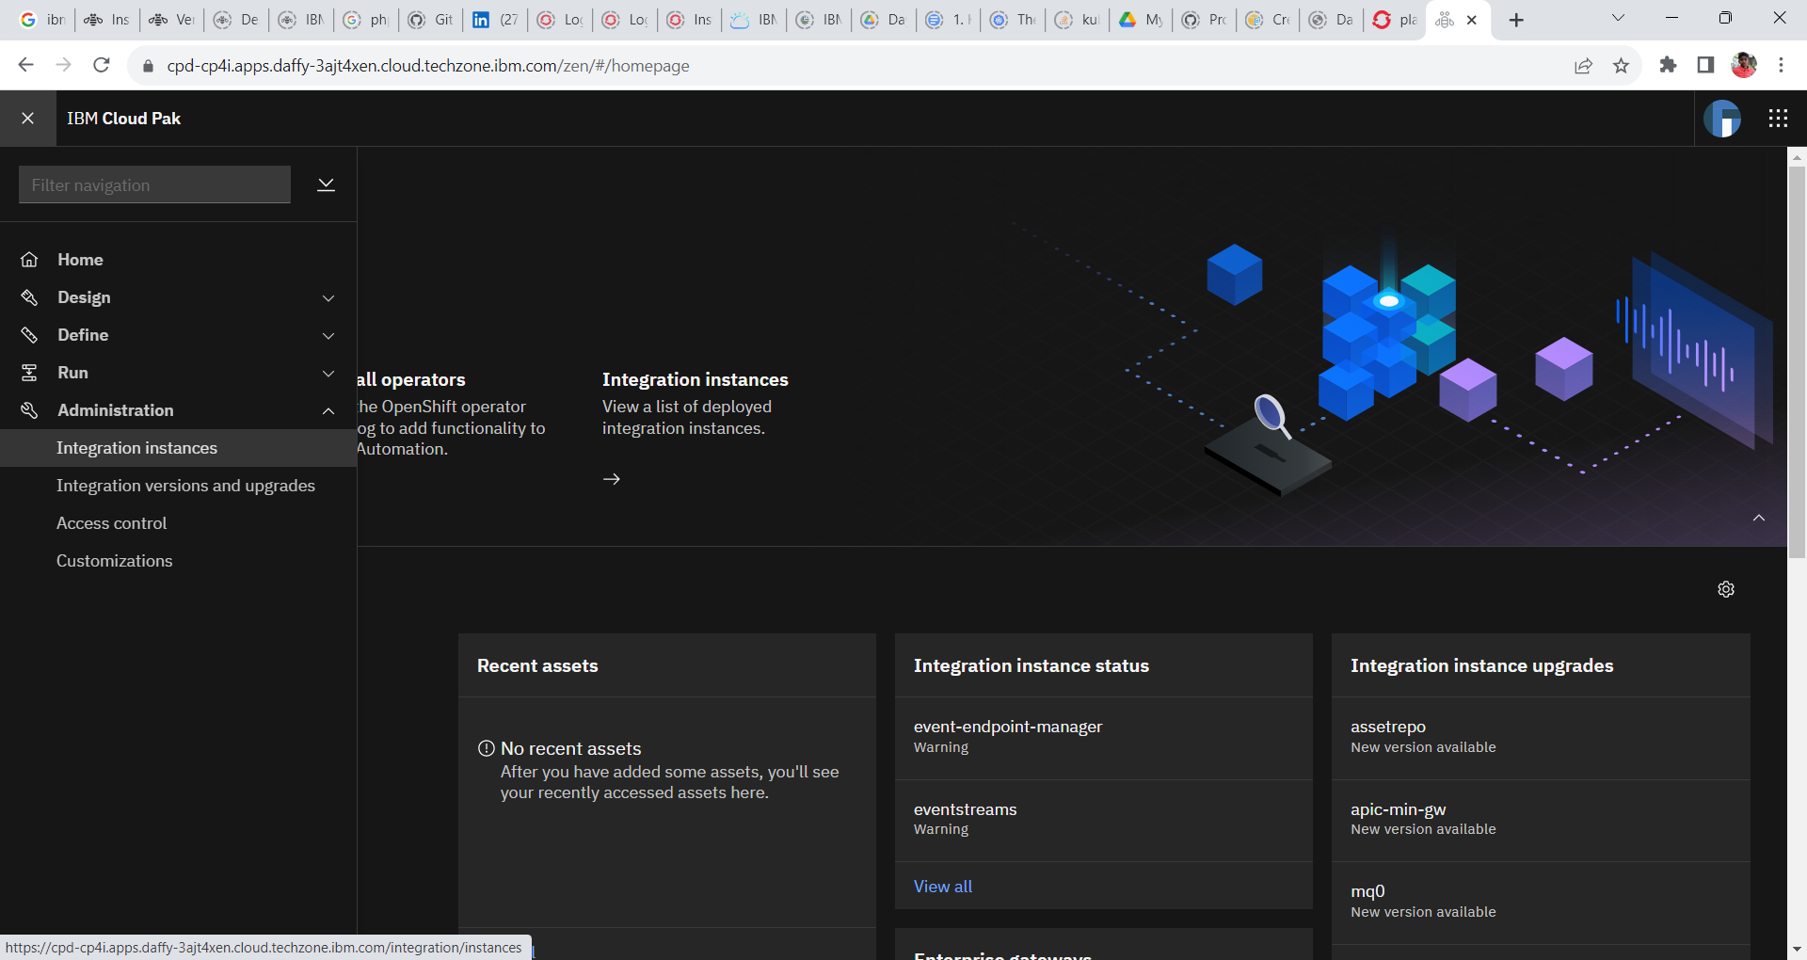

7. To create an instance of Integration Design. click **Create Instance** in the window

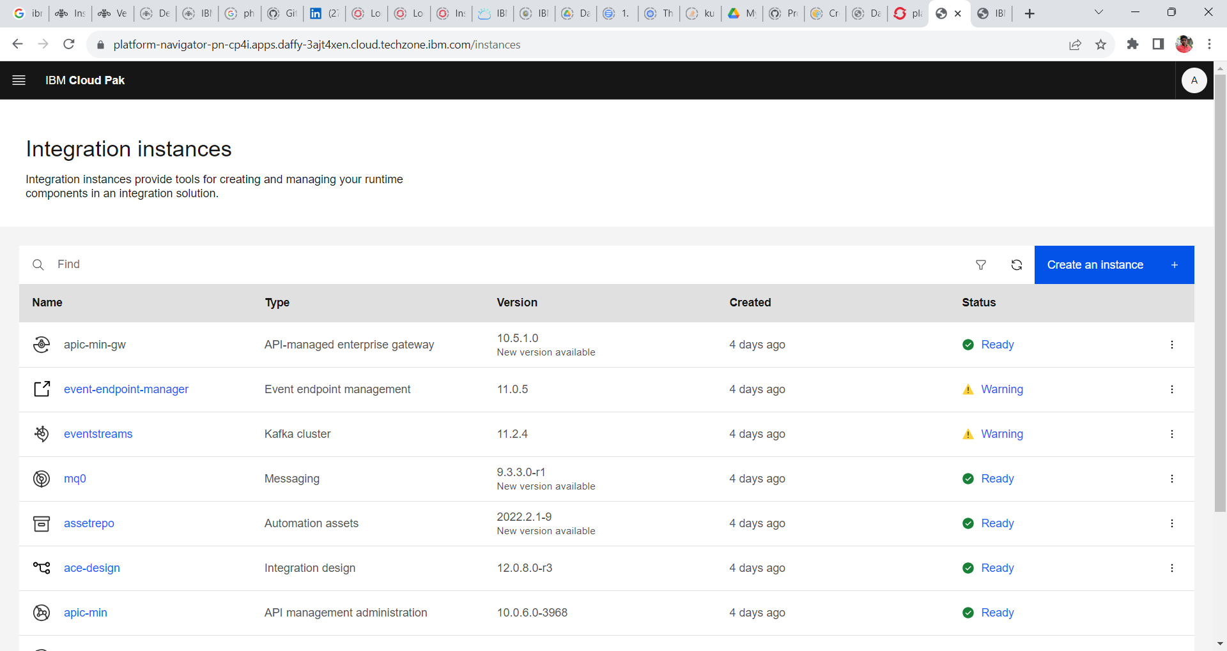

8. Select the **Integration Design** tile and click **Next**.

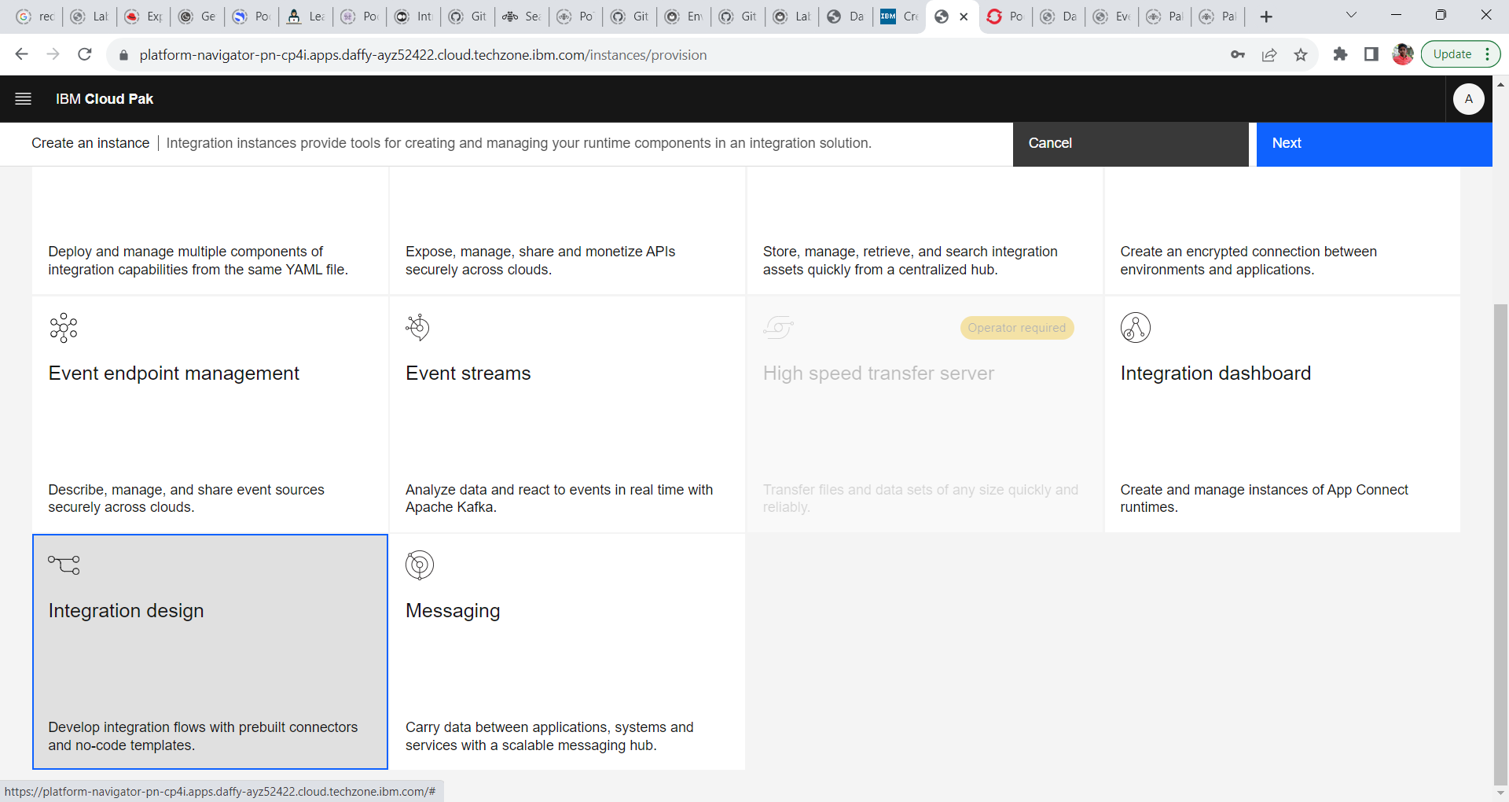

9. Next window displays the Sample tiles through which we can create the integration Dashboard instances. Select the **quick start tile** and click **Next**.

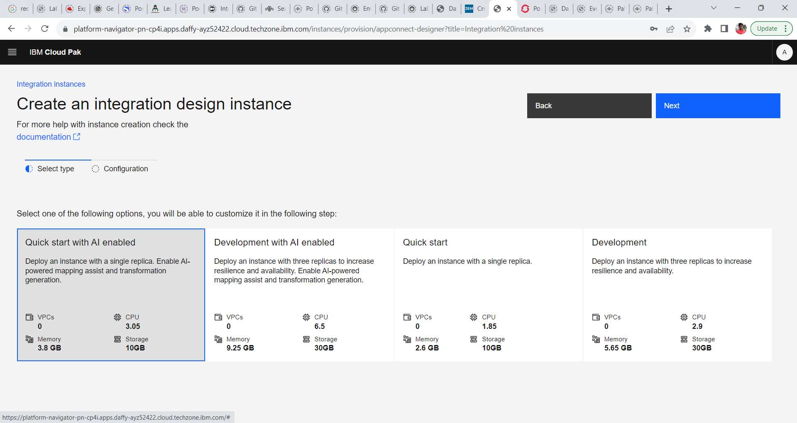

10. Provide the following configuration and create the Integration Design instance.

**Name : des-03-quickstart (if needed we change the name)**

**Namespace: cp4i**

**Channel or Version: 12.0-lts**

**License : Accept the License**

**License Use: CloudPakForIntegrationNonProdcution**

**Storage : ocs-storagecluster-rbd**

**Size: 10 Gi**

**Storage Type: Persistent-claim**

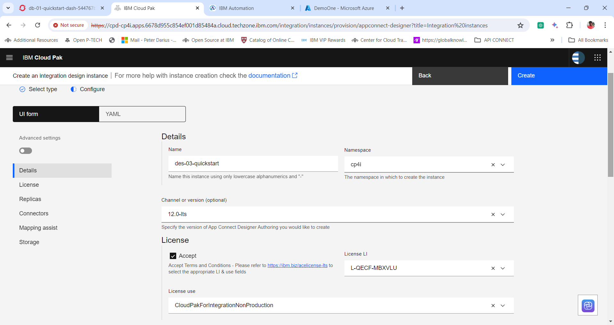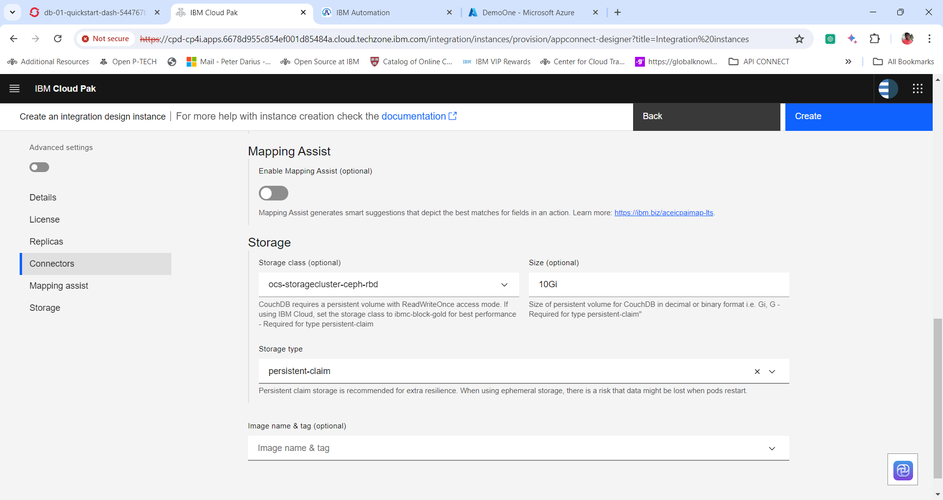

11. Click **Create** to create the instance. And wait for few minutes to spin up the Integration Design Instance.

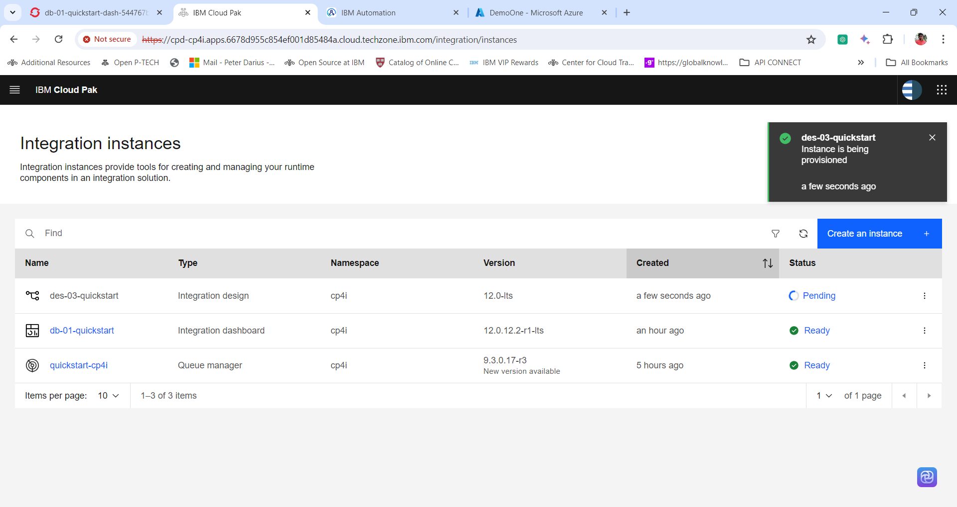

12. Once the installation is completed and the status is **ready** click on the **Integration Design instance Name** i.e ***des-03-quickstart*** to open the Integration Design Dashboard.

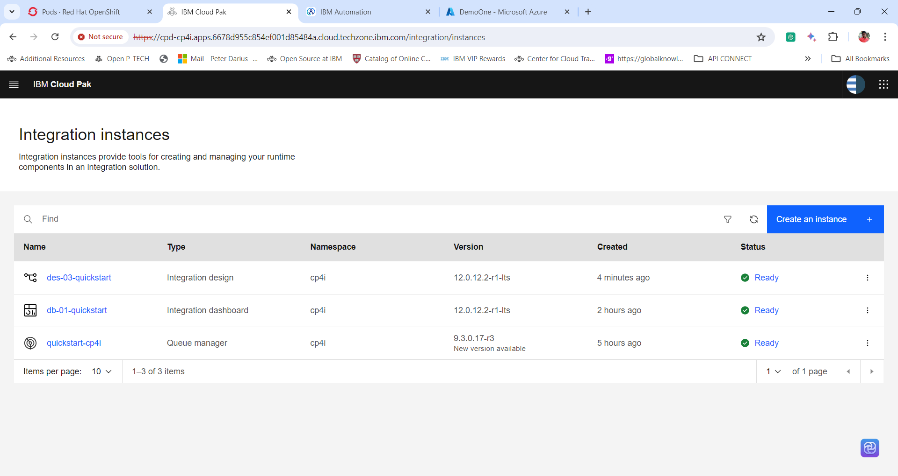

13. Integration Design Dashboard

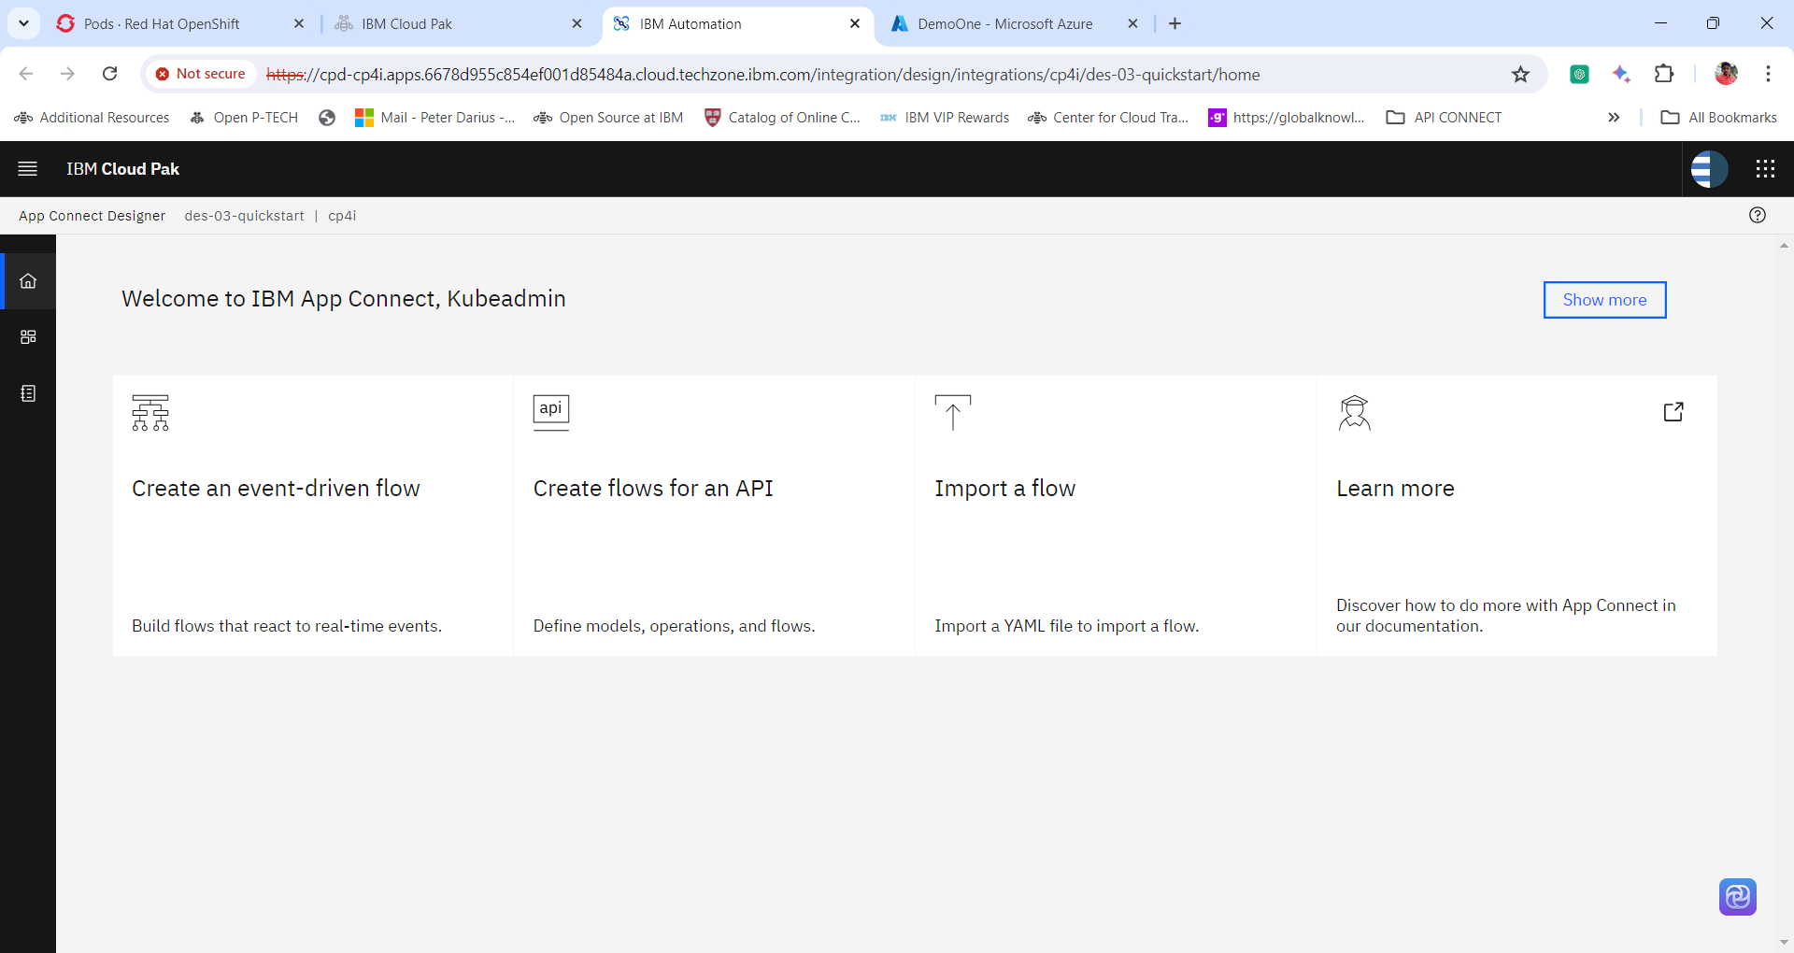

**Home**

**Dashboard**

**Catalog**

14. Let’s check the Integration Dashboard pods created. Login into the Red Hat OpenShift Console. Expand **workloads** and click **pods**.

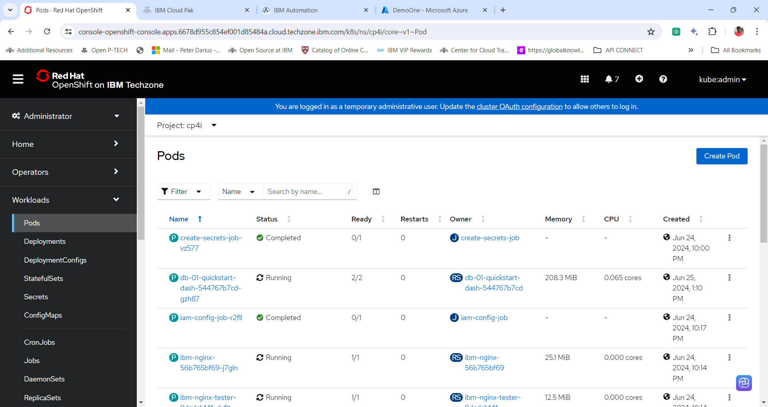

15. Change the **project Name to cp4i**. In the **search box** search integration dashboard pod by giving integration instance name i.e **des-03-quickstart.** And click the integration pod name to view the details of the pod.

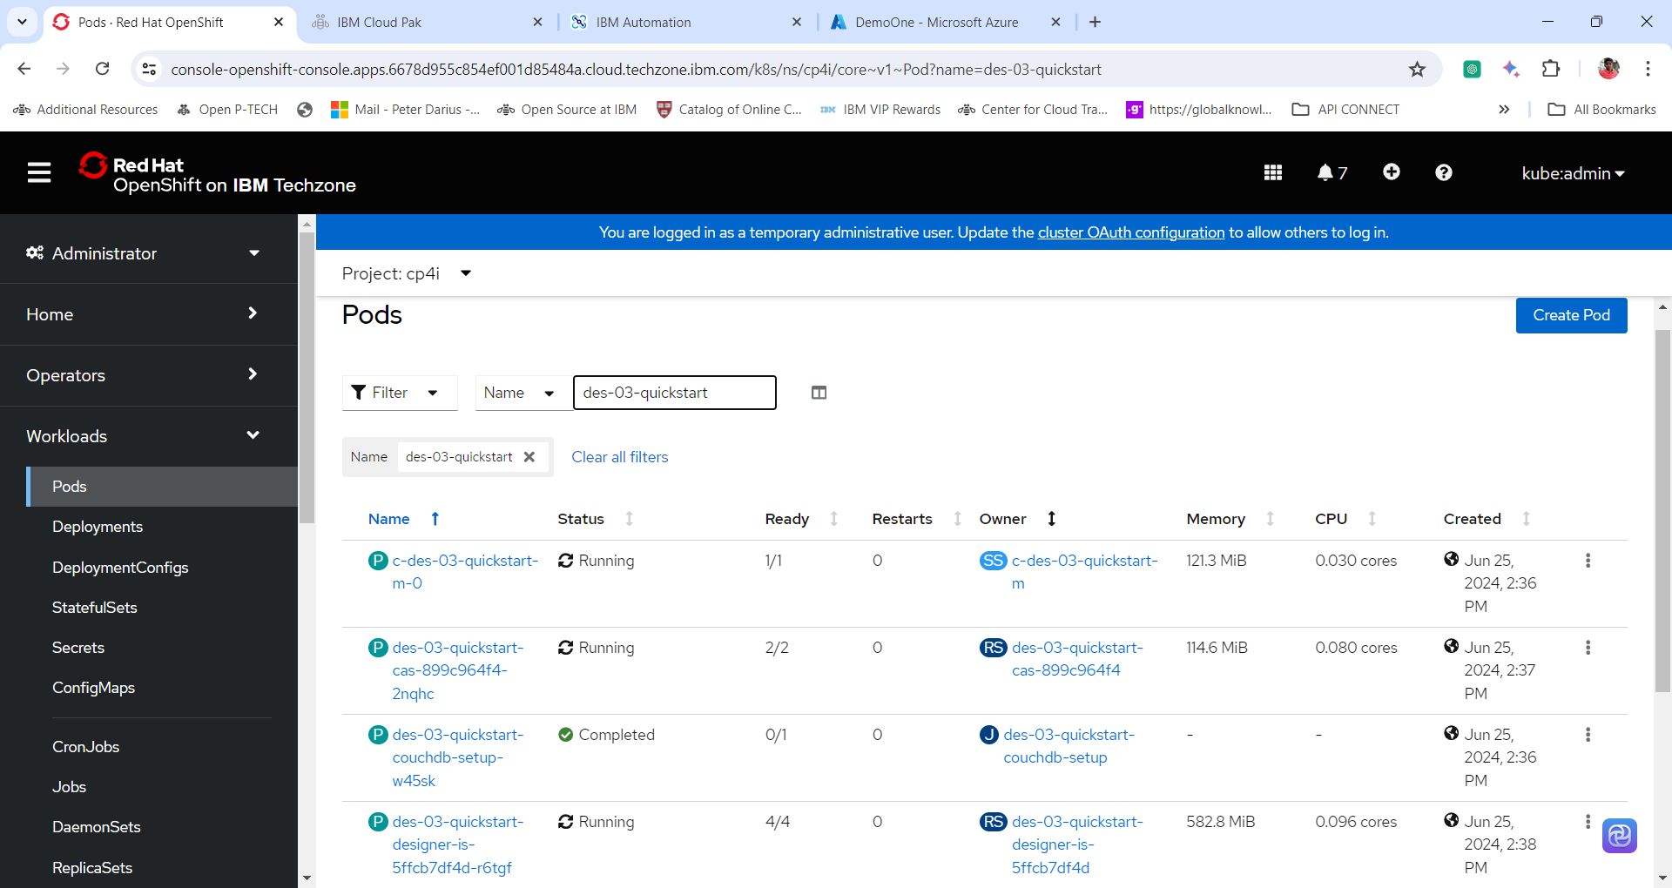

Thanks for successfully completing the Lab